Technical Specifications

Conformance Process for Specification and Acceptance Testing of LASC Communication Protocol
VERSION: [1.0] | REVISION DATE: 11/10/2009

Approver Name | Title | Signature | Date
Table of Contents
1 Introduction 4
1.1 Relationship to other systems 4
1.2 Project Environment 4
1.3 Contact information 4
2 System Description 5
3 Testing File Description 7
3.1 Testing File Layout 7
3.1.1 XML Keywords 7
3.2 Variables in XML 8
3.2.1 Input variables 8
3.2.2 Output variables 9
3.3 ASCII coded numbers in xml 9
3.4 Hex streams 9
3.5 Example Test project xml file 9
4 Events 11
4.1 Variable events – implemented in the architecture 11
4.1.1 set_variable 11
4.1.2 auto_increment_variable 11
4.1.3 increment_variable 11
4.1.4 clear_variables 11
4.2 Events Implemented in all redirects 12
4.2.1 TestReset 12
4.2.2 SuiteReset 12
4.2.3 ProjectReset 12
4.2.4 GetRedirectVersion 12
4.3 Core Redirect 14
4.3.1 wait 14
4.3.2 manual 14
4.3.3 input_text 14
4.3.4 ping_send 14
4.3.5 generate_profile 15
4.3.6 display_profile 15
4.3.7 display_image 15
4.3.8 compare_variables 16
4.4 EIP Redirect 17
4.4.1 tcp: open 17
4.4.2 tcp:close 17
4.4.3 tcp: send 18
4.4.4 tcp: receive 18
4.4.5 udp: open 18
4.4.6 udp:close 19
4.4.7 udp: send 19
4.4.8 udp: receive 19
4.4.9 eip: send 20
4.4.10 eip: receive 20
4.4.11 eip:set 21
4.4.12 eip:init 21
4.4.13 eds:check 21
4.5 EIP Redirect – LASC Level 2 specific 22
4.5.1 generate_face_profile 22
4.5.2 generate_rpc_profile 22
4.5.3 decode_ram_extensions 22
4.5.4 decode_leg_pressures 23
4.5.5 generate_horizon_adj_profile 23
4.5.6 generate_floor_height_profile 23
4.5.7 generate_floor_gradient_profile 24
4.5.8 decode_shearer_paramaters 24
4.5.9 eip_convert_data 24
5 Components and relationships 25
5.1 LASC Compliance Utility 25
5.2 Test Case Runner Class 25
5.3 Test Redirection Modules 26
5.3.1 ItemSummary class 26
5.4 Test Case Manager 27
5.5 Verification Manager 28
5.6 EDS Manager 28
6 Security/Safety 30
6.1 Testing mode 30
6.2 Report Validity 30
7 Audit Details 31
8 Environment Overview 31
9 Testing Overview 31
10 Installation Overview 31

Introduction
The aim of the project is to develop an industry-based conformance process for specification and acceptance testing of ACARP-developed technologies. For LASC technologies, a set of software tools will be produced to assist specification and conformance testing of OEM implementations against existing open LASC specifications. The framework for this process will also be able to accommodate future automation systems. Both manufacturers and customers will have open access to the software tools and each can test OEM automation systems for conformance with the LASC (and future) specifications.
In particular, this suite of software tools will perform the task of certifying compliance for all systems (software applications and devices) to The LASC Automation Communication Protocol.

Relationship to other systems
There are currently no existing systems that perform this task. Once this project is complete, there are a number of systems that will need to be checked for compliance:
Applications written by CSIRO:
SPMS_Client
Devices:
SPMS
OEM Shearer controllers
OEM Roof Support System controllers

Project Environment
The software developed by this project will be limited to a testing suite. As such, cross platform compatibility is not a major requirement of the project. The software will be developed in Microsoft Visual Studio using the C++ programming language. Every attempt will be made to keep the code base portable and re-useable, but the emphasis will be on a robust working product.
The software will be provided in the form of a binary executable, and an installer for Windows XP and Windows Vista will be provided as part of the completed product.
As a major part of this test suite will involve communications to an EIP device, the running platform must have access to an Ethernet device.

Contact information
Contact Mark Dunn
Phone +61 732274181
Fax +60 732274444
Email mark.dunn@csiro.au

System Description
This project comprises a number of different software components. The major component is the main testing application, but there are a number of ancillary tools that are also required for the maintenance and future enhancement of the system.
The testing system will look like this:

This testing system is designed to be generic enough to test any application, device, or protocol, with a flexible customisation architecture based on xml input files.
The main flow is as follows:
- A Testing project file (XML or Encrypted XML) is read in from a local file. A sample layout is provided below
- The EIP Device Model (electronic Datasheet or EDS) is read in if available
- Each test in each test suite is parsed and executed.
- Each event in the test is redirected by a suite of testing DLLs. The redirect functions have pre-defined input and output formats that must be adhered to.
Each testing session will look like this:
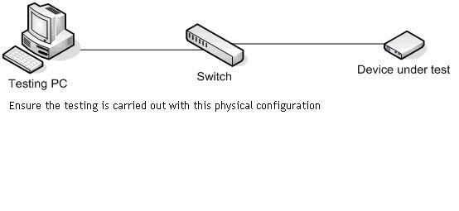

Testing File Description
Testing files are coded in XML and will generally be created and modified using the TestCaseManager utility.
The following sections describe the required format and functionality of testing files.
A project is a single file. Each project found on the search path will be given a separate tab in the final testing application. The LASC level1 project must exist or the application will fail.
A suite is a grouping of similar tests within the project, for example “Session Handling Tests” or “Message Handling Tests”. Each test suite may have setup and teardown steps. The setup phase may include opening ports, initialising global data and so on.
A test is the smallest level of definition for one complete ‘unit’ of functionality or requirement. The testing report will summarise tests passed and failed. A test can have defined attributes, and events.
An attribute is a pre-defined requirement that has to be met for the test to pass. An example of this is a timeout for a communication message, or a prerequisite test that must be completed first.
An event is a pre-defined unit of work that is applied to the system under test. These events are defined and coded external to the testing application. The definition file (described as a redirection herein) provides DLL names and callback objects. There are a set of basic testing events defined, these are defined in section 4.

Testing File Layout

XML Keywords
Project – There is exactly one project per xml/exml file.
Attributes:
- Name – the name of the project
- Version –the version of this release
The project tag is the description of the entire testing session. For example, LASC Level 1 compliance is one project.
Children:
- Suite
- Global
Global – a global is a reference to a fixed value that can be set up by the testing application. The global needs to be prefixed and suffixed with ‘$’ symbol e.g. $TCP_ADDRESS$. These symbols can then be used throughout the XML file and will be converted at run time with either an input value or a calculated value. This keyword may have no children.
Suite – A suite is a group of similar tests collected together under functional sets. An example is ‘Transfer protocols’ and ‘Session Handling’.
Attributes:
- Id – this attribute is mandatory
Children:
- description – mandatory for each test suite. A short description of the group of tests.
- setup - optional list of events that are to be run at the start of the suite before any tests are started
- test
- teardown –optional list of events to be performed before leaving the suite. This will contain clean up events
Test – The smallest unit of functional testing.
Attributes:
- Id – mandatory unique identifier
- Timeout – optional timeout for the test to complete
- Repeats – optional number of times to repeat the complete test
Children:
- Description – mandatory short description for the test name
- Fail_severity – 0-5 level = pass, minor, moderate, high, critical
- Extended_message – a more detailed description of the test, expected results and outputs.
- Event
Event – The smallest unit of redirectable testing.
Each event can perform some action through the redirect functions. An event may be input or output or modify some state or variable of the testing suite,
Children:
- Pre-defined events as per section 4, or implemented by new redirect modules.

Variables in XML
Variables can be entered in XML as both input and output variables.
Variable names can be of any length, but must not contain spaces or special characters other than underscore.

Input variables
A variable value may be read in from the output stage of any test. The variable will retain its value until the end of the suite.
An input variable is defined in the XML using ‘%’ delimiters front and back of the variable name e.g.:
%HANDLE1%
%SESSION_ID%
These variables must be returned by the specific redirect function, and will only be populated upon the return of that event. For more information, see section TODO: ref, Core redirect functions.

Output variables
A variable can also be substituted into the parameters by using ‘$’ delimiters front and back of the variable name e.g.:
$TCP_ADDRESS$
$PORT$
These variables can be set up globally in the project setup under the <global> tab in the test case manager, or altered programmatically by the testing software, or altered by reading in as an input variable.
There are several generic output variables that are populated by various redirect events:
- $DATA$ - generally set by any communication or EIP event, this variable contains the actual data received from the device.
- $STATUS$ - set by EIP events, this is set to the status of the response packet.

ASCII coded numbers in xml
As the testing files are written in xml, numbers are written in text and converted to numeric values internally to the testing utility. If numbers are to be interpreted as hexadecimal, they can be embedded in the xml with a preceding ‘0x’ characters. For example, the number 100 could be written ‘100’, or ‘0x64’

Hex streams
Some redirect events, for example tcp_send, may expect a stream of ASCII coded numerals that will be converted to a binary stream. These events will be documented as such.

Example Test project xml file
<?xml version="1.0" encoding="UTF-8"?>
<project name="Sample Project" version="0.0.a" xmlns:msg="Message_connector">
<suite id=1>
<description> Transfer Protocols</description>
<setup>
<tcp:open>address,port</tcp:open>
</setup>
<test id=1>
<description> TCP connection</description>
<input>
<wait>1000</wait>
<tcp:send>data here</tcp:send>
</input>
<output timeout=3000>
<tcp:receive>response here</tcp:receive>
</output>
</test>
<test id=2 prerequisite=1>
<description> UDP message</description>
<input>
<wait>1000</wait>
<udp:send>data here</udp:send>
</input>
<output timeout=3000>
<udp:receive>response here</udp:receive>
</output>
</test>

</suite>
<suite id=2>
<description>Common Services</description>
<setup></setup>
</suite>

</project>

Events

Variable events – implemented in the architecture

set_variable
This event sets the current value of a variable to a specific value. If the variable name exists, the value is altered. If the variable name does not exist, it is created.
Parameters:
- comma separated name, value pairs
Behaviour with no parameters: nil
Behaviour with excess parameters: ignore excess parameters
Return value: nil

auto_increment_variable
This event sets the auto increment for a particular variable. The variable value must be an integer. The increment value must be an integer. Each time the variable is referenced in testing, the given increment will be applied to the variable value.
Parameters:
- variable name, increment
Behaviour with no parameters: fail
Behaviour with excess parameters: fail
Return value: nil

increment_variable
This event applies an immediate increment to a variable value. The variable value must be an integer. The increment value must be an integer.
Parameters:
- variable name, increment
Behaviour with no parameters: fail
Behaviour with excess parameters: fail
Return value: nil

clear_variables
This event clears all the local variables accumulated in the testing suite to date. This is run automatically at the commencement of each suite.
Parameters: nil
Behaviour with no parameters: nil
Behaviour with excess parameters: nil
Return value: nil

Events Implemented in all redirects

TestReset
This event is called on each redirect file at the start of each test. This is to allow test-specific initialisation to be performed if required. This must be implemented in every Redirect DLL.
Parameters:
- nil
Behaviour with no parameters: redirect specific
Behaviour with excess parameters: redirect specific
Return value: nil

SuiteReset
This event is called on each redirect file at the start of each suite. This is to allow suite-specific initialisation to be performed if required. This must be implemented in every Redirect DLL.
Parameters:
- nil
Behaviour with no parameters: redirect specific
Behaviour with excess parameters: redirect specific
Return value: nil

ProjectReset
This event is called on each redirect file at the start of each project. This is to allow project-specific initialisation to be performed if required. This must be implemented in every Redirect DLL.
Parameters:
- nil
Behaviour with no parameters: redirect specific
Behaviour with excess parameters: redirect specific
Return value: nil

GetRedirectVersion
This event is called on each redirect file at load time. The version should be a dotted 2 number version in the format major.minor, e.g. “1.0”. This version is reported as part of the compliance report.
Parameters:
- nil
Behaviour with no parameters: redirect specific
Behaviour with excess parameters: redirect specific
Return value: variables $data$, version

Core Redirect
The list of events populated in the Project-supplied CoreRedirect.dll

wait
This event pauses the testing process for the required number of milliseconds. This can be used to wait for messages or slow down tests.
Parameters:
- 1parameter= milliseconds, coded in decimal. E.g. 1000=1 second.
- 2parameters = minimum random time, maximum random time, coded in decimal. E.g. 1000,2000 will pause for a random duration between 1 and 2 seconds
Behaviour with no parameters: return with no wait
Behaviour with excess parameters: use first 2 parameters for random wait
Return value: nil

manual
This event pops up a message box to prompt the user to take some action. There is an OK button for the user to continue the testing process.
Parameters: Text string – the message displayed on the popup
Behaviour with no parameters: Display blank popup
Behaviour with excess parameters: Use first parameter as string
Return value: SUCCESS if user presses OK, FAIL if user presses Cancel.

input_text
This event pops up a dialog box to prompt the user to enter some data. There is an OK button for the user to continue the testing process.
Parameters: Text string – the message displayed on the popup
Behaviour with no parameters: blank question
Behaviour with excess parameters: Use first parameter as text string
Return value: variable $DATA$, user entered text box string

ping_send
This event pings a device on a particular network address to test for connectivity. It allows one second for a response.
Parameters: IPaddress coded in dotted text e.g. 140.253.33.134
Behaviour with no parameters: fail
Behaviour with excess parameters: ignore
Return value: nil

generate_profile
The event generates a comma separated list of values for use as a signal, given some required function
Parameters: number of points – will generate a random number for each point
sin, number or points – will generate a sin wave pattern
Behaviour with no parameters: nil
Behaviour with excess parameters: nil
Return value: variable $DATA, comma separated list of values

display_profile
This event displays a graph of a signal in a popup box and presents the user with an OK button to continue
Parameters: comma separated values – display a graph of the raw numbers provided
Sin, number of points – display a graph of a sin wave with this number of points
HEADING=text string to display, comma separated values – as above, with required dialog box heading
Behaviour with no parameters: FAIL
Behaviour with excess parameters: nil
Return value: SUCCESS if user presses OK, FAIL if user presses Cancel.

display_image
This event displays an image in a popup box and presents the user with an OK button to continue
Parameters: image filename – displays the bmp or jpg image
Behaviour with no parameters: FAIL
Behaviour with excess parameters: nil
Return value: SUCCESS if user presses OK, FAIL if user presses Cancel.

compare_variables
This event compares the values of variables, allows equality, inequality and less than, greater than
Parameters: <,var1,var2, returns SUCCESS if var1< var2, else FAIL
>,var1,var2, returns SUCCESS if var1>var2, else FAIL
=,var1,var2,..var n, returns SUCCESS if var1=var2=var3=..=var n, else FAIL
!=,var1,var2,…var n returns SUCCESS if var1!=var2!=… != var n, else FAIL
Behaviour with no parameters: nil
Behaviour with excess parameters: nil
Return value: as per the parameter list

EIP Redirect
This section details the existing events in the EIPRedirect.dll and the parameters specified for each event. Note that if these events are overridden in other redirectors, the base functionality for the given set of parameters MUST remain the same.
Parameters are all coded in ASCII. Decimal numbers are as written.
Hexadecimal numbers are entered in ASCII form. E.g. 1000 may be written as 0x03E8.
Handles for communications channels must be prefaced with * e.g. ‘*1’

tcp: open
This event opens a TCP channel to the given IP address and port. The handle is stored for future use. If the handle is omitted, 0 is used.
Parameters: tcp_address, port, handle
Behaviour with no parameters: fail
Behaviour with excess parameters: attempt connection using address, port
Return value: FAIL on communications error, else SUCCESS

tcp:close
This event closes a TCP socket.
Parameters: handle
Behaviour with no parameters: attempt to close global TCP session if it exists
Behaviour with excess parameters: close global TCP session if it exists
Return value: FAIL on communications error, else SUCCESS

tcp: send
This event converts the ASCII coded hex string into a binary array and sends it via either the handle if supplied, or the global handle otherwise
E.g. To send the byte stream ‘0123’, code as ‘0123’. To send the character stream ‘0123’, code as ‘30313233’.
Parameters: ASCII coded hex string, handle
Behaviour with no parameters: fail
Behaviour with excess parameters: send first parameter
Return value: FAIL if handle is not a valid communications channel
FAIL on communications error, else SUCCESS

tcp: receive
This event receives data from the TCP handle if supplied, or else the globally opened handle. The handle parameter is ALWAYS last, regardless of how many input parameters exist
Parameters:
ASCII coded hex expected response string, handle - this will check for the expected response string exactly.
ASCII coded hex expected response string with ?? placeholders for variables, %var1, … , %var n%, handle - this will check for the expected response string exactly, allowing any chars for placeholders and filling the variable values with the chars received. Eg ‘6300??00,var1,*1’
ASCII coded hex expected response string* - this will receive as many characters in the given timeout limit as possible, but only require matching up to the wildcard * symbol. Eg ‘6300*’
Behaviour with no parameters: test for null data received.
Return value:
SUCCESS if data matched, else FAIL.
Variables populated as required
Actual data received in $data$

udp: open
This event opens a UDP connectionless channel to the given IP address and port. The handle is stored for future use. If the handle is omitted, 0 is used.
Parameters: udp_address, port, handle
Behaviour with no parameters: fail
Behaviour with excess parameters: attempt connection using address, port
Return value: FAIL on communications error, else SUCCESS

udp:close
This event closes a UDP socket.
Parameters: handle
Behaviour with no parameters: attempt to close global UDP session if it exists
Behaviour with excess parameters: close global UDP session if it exists
Return value: FAIL on communications error, else SUCCESS

udp: send
This event converts the ASCII coded hex string into a binary array and sends it via either the handle if supplied, or the global handle otherwise
Eg To send the byte stream ‘0123’, code as ‘0123’. To send the character stream ‘0123’, code as ‘30313233’.
Parameters: ASCII coded hex string, handle
Behaviour with no parameters: fail
Behaviour with excess parameters: send first parameter
Return value: FAIL if handle is not a valid communications channel
FAIL on communications error, else SUCCESS

udp: receive
This event receives data from the UDP handle if supplied, or else the globally opened handle. The handle parameter is ALWAYS last, regardless of how many input parameters exist
Parameters:
ASCII coded hex expected response string, handle - this will check for the expected response string exactly.
ASCII coded hex expected response string with ?? placeholders for variables, %var1, … , %var n%, handle - this will check for the expected response string exactly, allowing any chars for placeholders and filling the variable values with the chars received. Eg ‘6300??00,var1,*1’
ASCII coded hex expected response string* - this will receive as many characters in the given timeout limit as possible, but only require matching up to the wildcard * symbol. Eg ‘6300*’
Behaviour with no parameters: test for null data received.
Return value: SUCCESS if data matched, else FAIL.
Variables populated as required
Actual data received in variable $data$

eip: send
Sends an EIP packet via UDP or tcp, depending on the handle. This command will automatically populate a correct EIP packet.
Parameters: one of:
- ASCII coded hex packet
- ASCII coded hex packet, handle
- command (works instead of packet in all formats above). The command can be one of:
  - 0x4 (listservices),
  - 0x63 (listidentity),
  - 0x0 (NOP),
  - 0x65 (registersession),
  - 0x66 (unregistersession).
- Command 0x6f, class, instance, attribute, service, handle (opt). note that if instance is not required, the comma placeholder should still be used in the string e.g. class,,attribute,service.
Behaviour with no parameters: fail
Return value: nil

eip: receive
Receives a valid EIP response packet.
Parameters: one of:
- ASCII coded hex expected response (last x bytes)
- ASCII coded hex packet, handle
- command (works instead of packet in all formats above),extra data. The command can be one of:
  - 0x4 (listservices), – also checks the response data against data listed in the EDS,
  - 0x63 (listidentity) – also checks the response data against data listed in the EDS,
  - 0x0 (NOP),
  - 0x65 (registersession),
  - 0x66 (unregistersession).
This will check mandatory response components of the message. Also note that passing in any variables containing the following substrings will populate with the appropriate values:
  - ID (session handle)
  - STATUS (message status)
- FAIL,error code,handle. This event coding will check for a FAILED EIP message- i.e., the general status code non zero
Behaviour with no parameters: fail
Return value: ASCII coded hex response
Variables populated as required
Actual data received in variable $data$

eip:set
This event sets the current EIP parameters → session id and message context. These are used for automatically generating correct packets in eip_send
Parameters:
- sessionid, message context, handle
If either the sessionid or message context is 0, the current automatically generated value will not be changed.
Behaviour with no parameters: fail
Return value: ASCII coded hex response

eip:init
This event initialises the EIP redirect dll with the EDS file data for use in further testing. This event is called automatically at the start of any suite with EIP functionality.
Parameters:
- EDS file name
Behaviour with no parameters: fail
Return value: nil

eds:check

This event is used to run tests against the current EDS file configuration. It can be called initially to get the number of items, and then called once for each item to be tested
Parameters:
• COUNT - This returns the number of parameters in the variable $eds_count$. This variable can then be used to call the eds:check event multiple times
• Handle - This will test the next item in the EDS file using the communications handle
• No parameters – This will test the next item in the EDS file using the global handle
Behaviour with no parameters: test the next item in the EDS file
Return value: nil

EIP Redirect – LASC Level 2 specific
This section details the existing events in the EIPRedirect.dll specifically written for LASC Level 2 testing.

generate_face_profile
This function generates the data for: EIP class 4, instance 2, attribute 3 set (face profile) in the correct binary format
Parameters:
• sequence number, space separated profile values
Behaviour with no parameters: fail

Return value: variable $DATA$, binary string for EIP message

generate_rpc_profile
This function generates the data for: EIP class 4, instance 1, attribute 3 set (RPC profile) in the correct binary format
Parameters:
• sequence number, space separated profile values
Behaviour with no parameters: fail
Return value: variable $DATA$, binary string for EIP message

decode_ram_extensions
This function decodes the binary data from EIP message: class 4, instance 3, attribute 3 GET (ram extensions) into a space separated list
Parameters:
• binary EIP data
Behaviour with no parameters: fail
Return value: variable $DATA$, space separated list of values

decode_leg_pressures
This function decodes the binary data from EIP message: class 4, instance 3, attribute 4 GET (leg pressures) into a space separated list
Parameters:
• binary EIP data
Behaviour with no parameters: fail
Return values:
- variable $LEGDATA1$, space separated list of values
- $SETDATA1$, space separated list of values
- $LEGDATA2$, space separated list of values
- $SETDATA2$, space separated list of values
- $LEGDATA3$, space separated list of values
- $SETDATA3$, space separated list of values
- $LEGDATA4$, space separated list of values
- $SETDATA4$, space separated list of values

generate_horizon_adj_profile
This function generates the data for: EIP class 4, instance 101, attribute 3 set (horizon adjustment profile) in the correct binary format
Parameters:
• sequence number, space separated profile values
Behaviour with no parameters: fail
Return value: variable $DATA$, binary string for EIP message

generate_floor_height_profile
This function generates the data for: EIP class 4, instance 102, attribute 3 set (floor height profile) in the correct binary format
Parameters:
• sequence number, space separated profile values
Behaviour with no parameters: fail
Return value: variable $DATA$, binary string for EIP message

generate_floor_gradient_profile
This function generates the data for: EIP class 4, instance 102, attribute 3 set (floor gradient profile) in the correct binary format
Parameters:
• sequence number, space separated profile values
Behaviour with no parameters: fail
Return value: variable $DATA$, binary string for EIP message

decode_shearer_paramaters
This function decodes the binary data from EIP message: class 4, instance 3, attribute 3 GET (ram extensions) into a space separated list
Parameters:
• binary EIP data
Behaviour with no parameters: fail
Return value: variable $DATA$, text string containing parameter name, value for manual checking

eip_convert_data
This function converts from ASCII coded hex to a series of variables given a list of formats to convert into.
Parameters:
• raw data, output format(/s): e.g. 00101020,REAL,REAL
- formats are: REAL, LREAL, INT, UINT, DINT, UDINT, LINT, ULINT , SINT, USINT, WORD, DWORD, IP
Behaviour with no parameters: fail
Return value: variables : $DATA1$,value, $DATA2$,value,… etc

Components and relationships
This section covers all system components in their minimal form. This may be applications, modules or even functions, depending on the level of complexity of the system. For a hardware project, this will also include each modular hardware component.

LASC Compliance Utility
See doxygen generated documentation at: \ComplianceUtility\html\index.html
The compliance utility is the main front end GUI for the testing functionality instantiated in the Project class.
This utility handles the selection of available testing projects, some user interface configuration, and display and printing of results.

Test Case Runner Class
This class handles the creation of threads and timing, as well as making the relevant calls to the appropriate redirect DLL.
The testredirector class doxygen is available from the link \ComplianceUtility\html\index.html

Test Redirection Modules
CoreRedirect – The basic testing functionality, consists of the events listed above.
For extensions, the following requirements apply
- The redirection modules are compiled as a DLL.
- Each new exported function (Test Event) is written as a function that accepts an ItemSummary pointer.
- Each new test returns a Boolean – false for event fail, true for success.
- The module contains at least: TestReset, SuiteReset, ProjectReset, GetRedirectVersion

ItemSummary class
The ItemSummary class provides the parameters and functionality for return values and error codes. The ItemSummary is inherited by each of the event, test, testsuite and project classes.

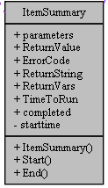
parameters
The format of the parameters member for any event should be clearly defined in the documentation. (see Section 4 above)
ReturnValue.
Used internally by the testing architecture
ReturnString
This is used to print debug information into the log message area
ReturnVars
This field is used to pass filled variables back to the testing architecture. The variables are in a comma separated name, value pair list
TimeToRun
This field is automatically populated with the elapsed time for the item
Completed
The completed field is a flag to indicate that the item has been run since loading.

Test Case Manager
The test case manager is a utility designed for OEMs and Development teams to design and unit test complete testing suites for new devices and software.
This utility has been designed to be flexible and extensible so that new projects and devices have test projects implemented easily and effectively.
Documentation can be found online at \TestCaseManager\html\index.html
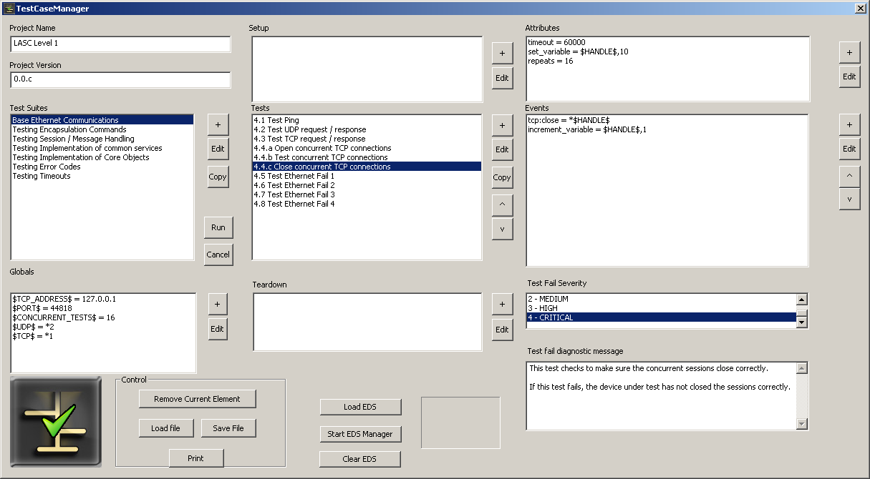

Verification Manager
This binary utility will be provided as part of the suite to ensure that any given testing suite project file or compliance report is authentic.
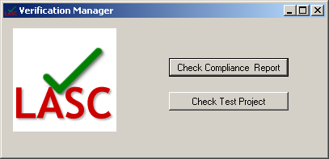
Documentation can be found online at VerificationManager\html\index.html

EDS Manager
This utility is provided as a means of easily editing the Electronic DataSheet file that is supplied with each LASC compliance device.
The EDS format will be a basic xml definition, with the following hierarchy:
- Device
  - Class
  - Attribute (class)
  - Instance
    - Attribute (Instance)
A Device will have xml attribute ‘Name’
A class will have xml attributes:
- Id – the EIP class id
- Name
- Mandatory – specifies that the class is mandatory, currently classes 1, 245 and 246
An instance will have xml attributes:
- Id – the EIP class identifier
- Name
- Mandatory – specifies that the class is mandatory, currently classes 1, 245 and 246
An attribute may belong to a class or an instance, and will have the following xml attributes:
- Id
- Name
- Mandatory
An attribute is the only tag allowed a value. If there is a value, this will be the expected response from the device under test. If there is no value coded in the EDS file, any value will be accepted in the response, but there must be a valid response.

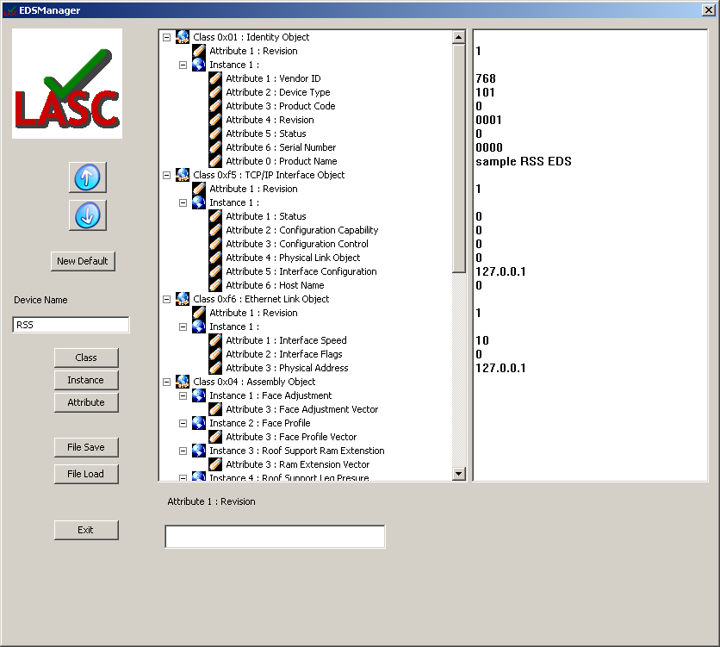

Documentation may be found online at \ EDSManager\html\index.html

Security/Safety

Testing mode
Note that this system should only be run on systems that are connected in testing mode only. There may be unforseen and unintentional consequences brought about by the purposeful introduction of corrupt or badly formed instructions.
The systems (especially devices with physical interactions) MUST be constrained in a safe manner. This constraint will be the responsibility of the testing operator or the system owner.

Report Validity
The final testing report generated by the system will include an embedded verification code that is produced only by this testing system. The report will identify all extension test-case addins that were used during the testing and which version of each. In this way, the end user of the systems can be assured that the testing regime was vigorous and appropriate.

Audit Details
The development of this project will be handled as a standard project in the CSIRO E&M team, which includes the following:
- Check in control using Subversion to Automation-ph server
- Documentation uploaded to TWiki regularly at
http://automation-ph/twiki/bin/view/Micta/SoftwareVerification
- Regular peer review design meetings and code walkthroughs where appropriate

Environment Overview
The operating environment will be:
- Windows XP standalone desktop PC or Laptop
- Access to LAN with connection to device under test

Testing Overview
For this system, the testing regime will be iterative over the development life of the project. Initially, testing will assume that the current existing devices and software under test are fully functional and correct. Test suites will be created for each system, and errors purposefully introduced.
A TRAC subsystem will be created for this project and all defects and enhancement requests will be created for logging and tracking on this system.
- The testing will be carried out in two stages. The first stage will be unit testing by the developer or team of developers. The second stage will be user acceptance test, where the software will be tested by a user new to the system, with only the software documentation as a guide in the first instance.
- A Beta release is scheduled for an industry testing phase in July 2009. Any results from this phase will be reported back to the development team for review.

Installation Overview
A full installation binary has been produced using a Nullsoft NSIS installer scriupt, as well as user documentation for installing and running the software. The document ‘LASC Certification Suite User Guide.doc’ contains more details.

Version | Description of Change | Author | Date
1.0 | Created | Mark Dunn | 4/2/08

